import matplotlib.pyplot as plt

import numpy as np

# Generate x values from 0 to 2π with 100 points

x = np.linspace(0, 2*np.pi, 100)

# Calculate sine values for each x

y = np.sin(x)

# Plot the sine wave

plt.plot(x, y)

plt.xlabel('x')

plt.ylabel('sin(x)')

plt.title('Sine Wave')

plt.grid(True)

plt.show()

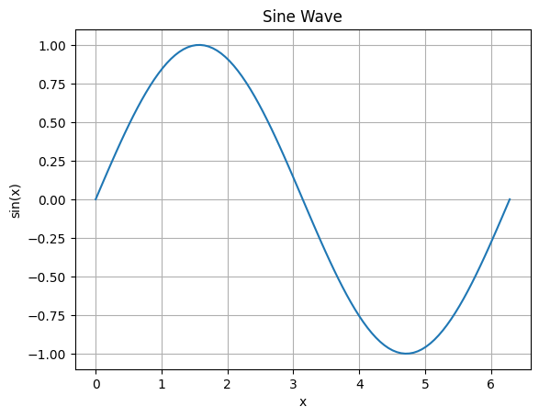

import pandas as pd

# Load the dataset from a CSV file

df = pd.read_csv('/content/sample_data/california_housing_train.csv')

# Display the first 5 rows

print(df.head())

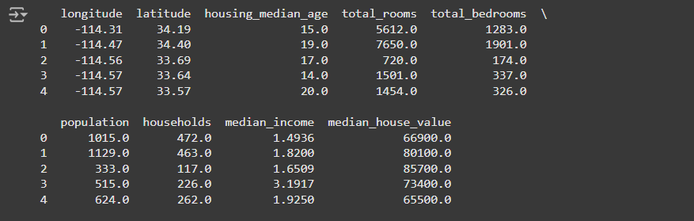

# Get information about the dataset

print(df.info())

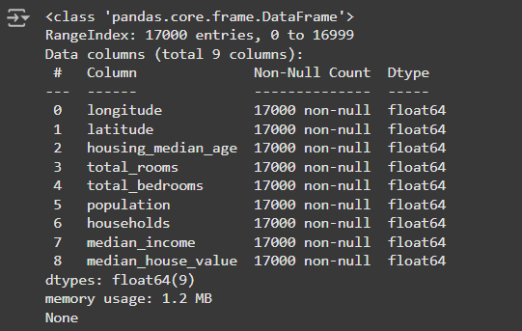

# Calculate basic statistics

print(df.describe())

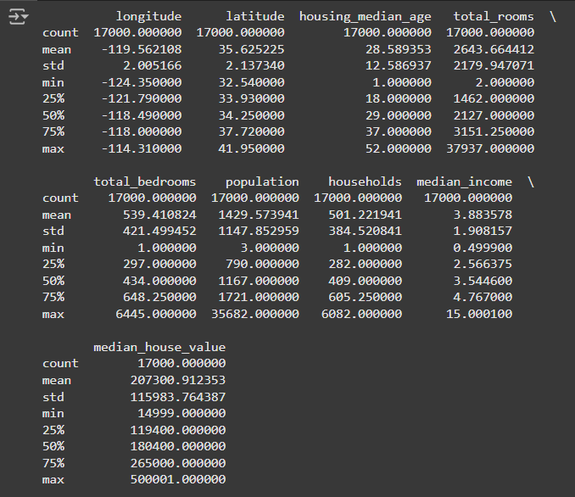

**A Simple Machine Learning Pipeline in Google Colab**

A basic machine learning pipeline demonstrating how to train a simple linear regression model on a dataset

import pandas as pd

import numpy as np

from sklearn.model_selection import train_test_split

from sklearn.linear_model import LinearRegression

from sklearn.metrics import mean_squared_error

# Load the dataset

data = {'X': [1, 2, 3, 4, 5], 'y': [2, 4, 5, 4, 5]}

df = pd.DataFrame(data)

# Split data into features (X) and target variable (y)

X = df[['X']]

y = df['y']

# Split data into training and testing sets

X_train, X_test, y_train, y_test = train_test_split(X, y, test_size=0.2, random_state=42)

# Create a linear regression model

model = LinearRegression()

# Train the model on the training data

model.fit(X_train, y_train)

# Make predictions on the testing data

y_pred = model.predict(X_test)

# Evaluate the model's performance

mse = mean_squared_error(y_test, y_pred)

print("Mean Squared Error:", mse)

